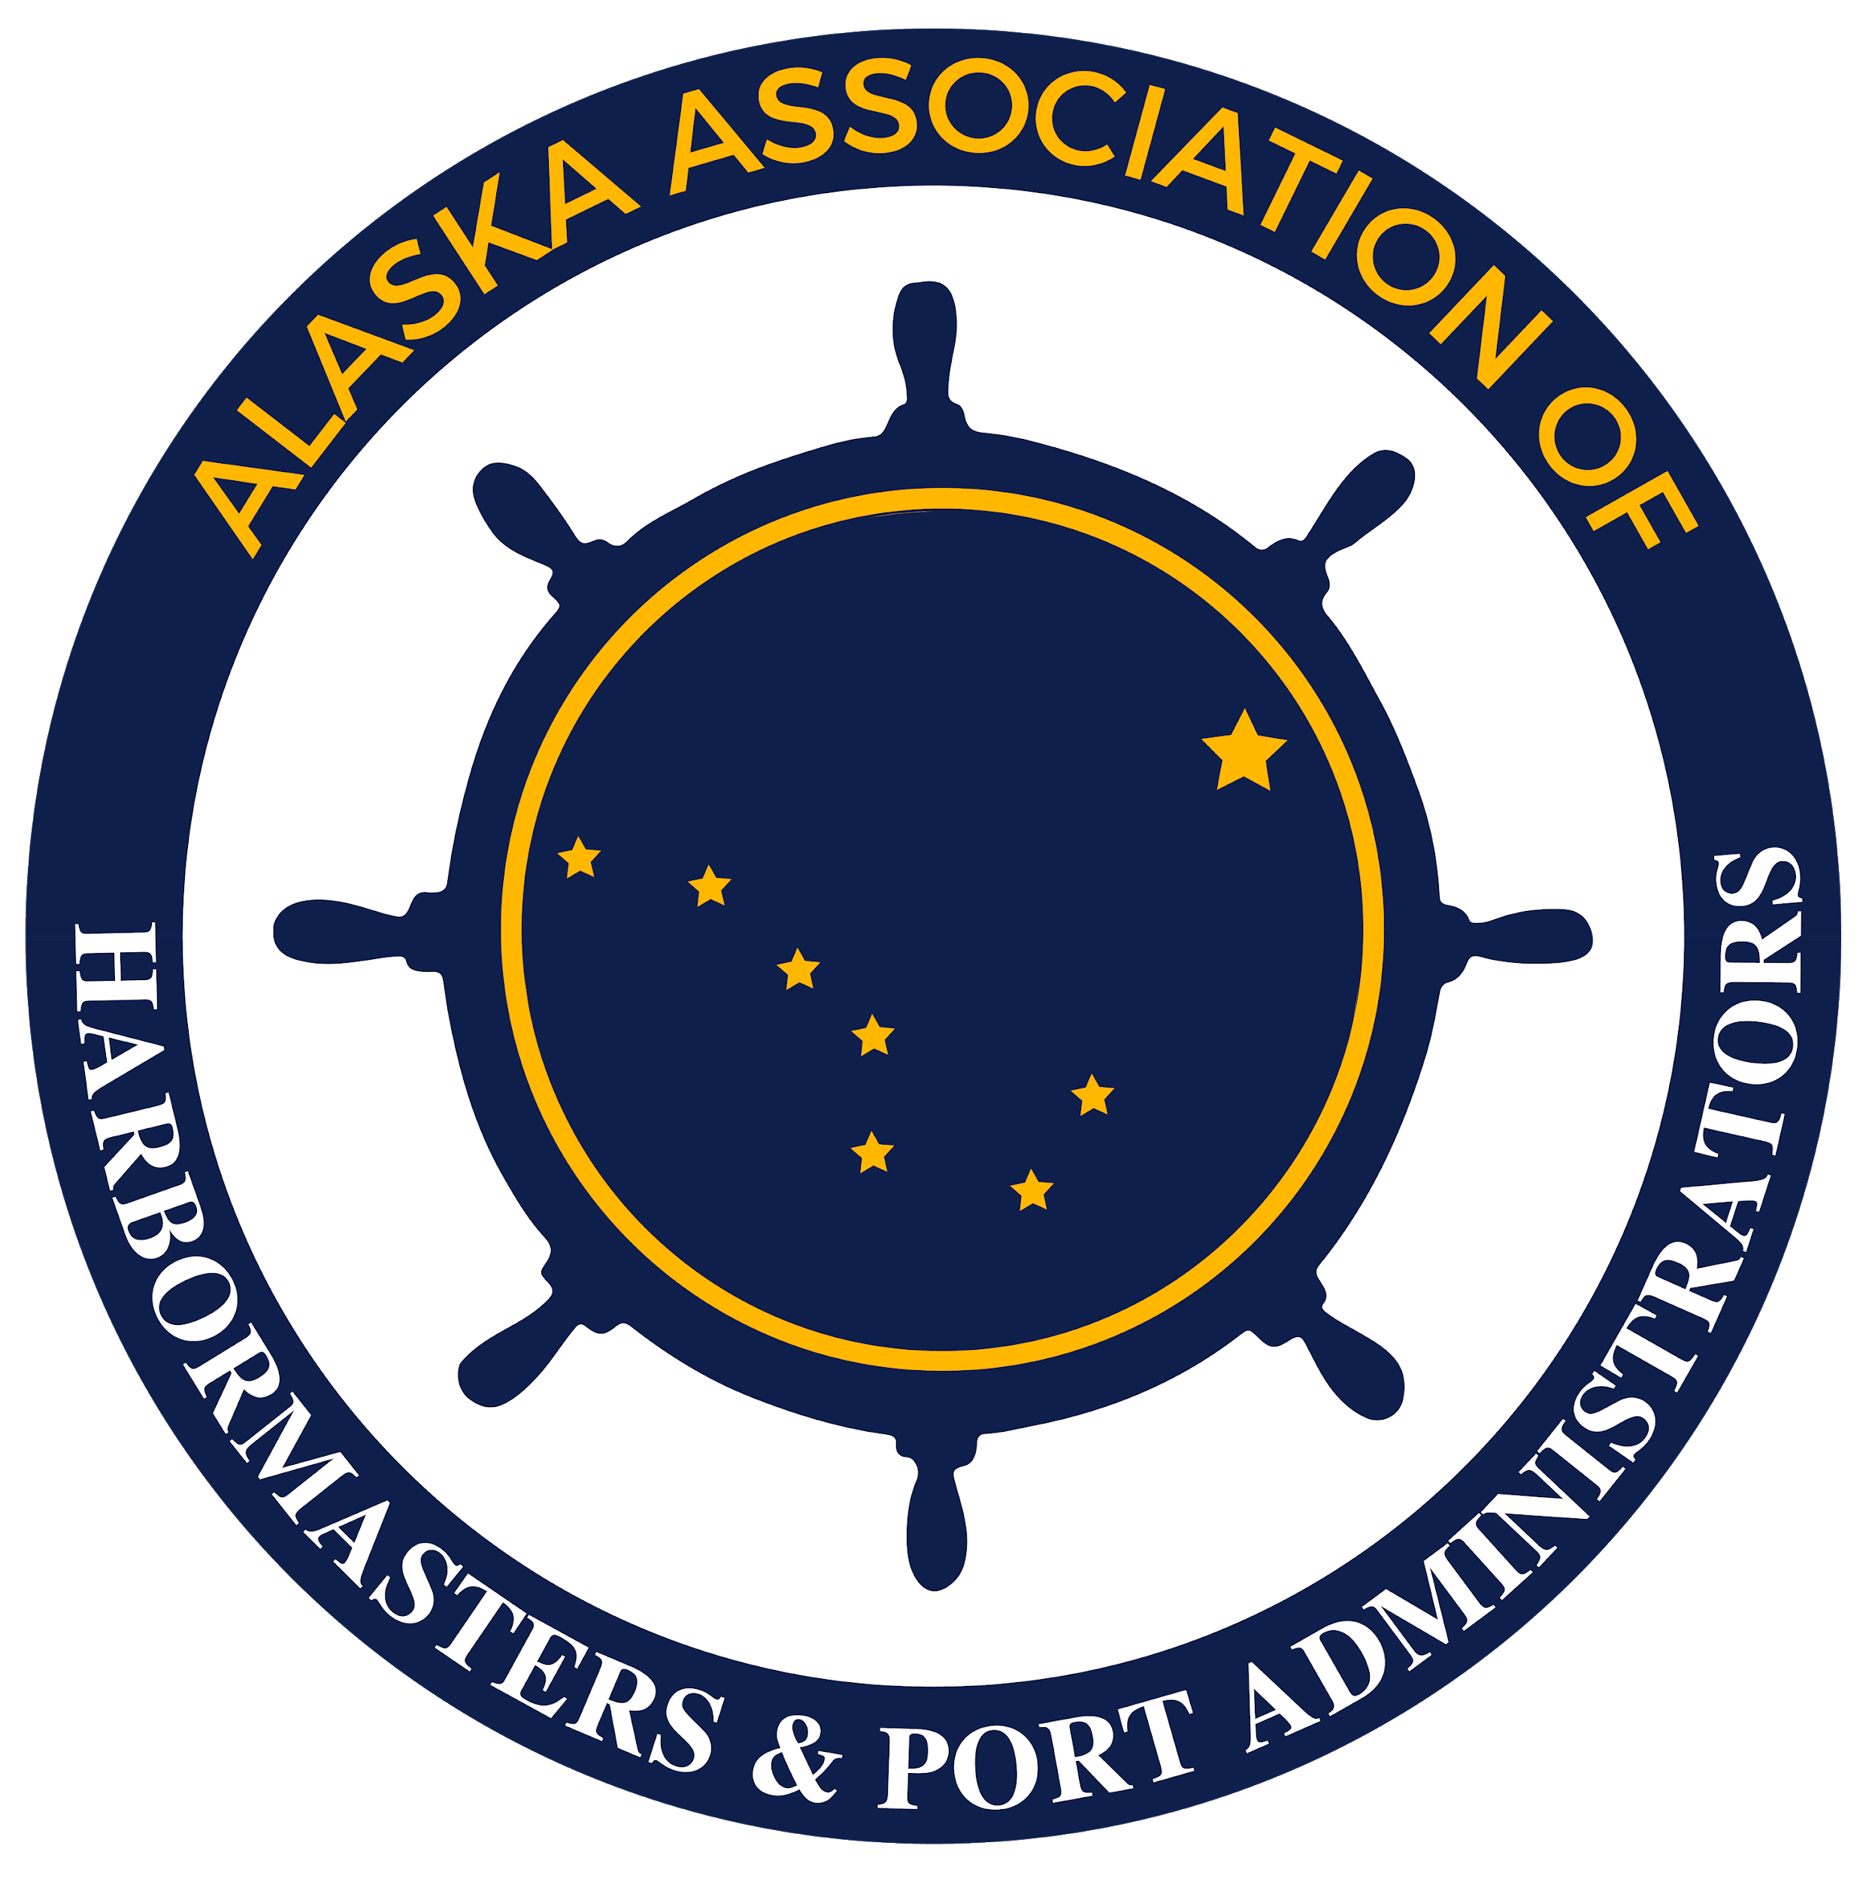

Alaska Association of Harbormasters and Port Administrators
2022 Scholarship Application

Application for a scholarship for an Alaskan student entering college or vocational school interested in pursuing a maritime career. Two $3,400 scholarships are available. Applications due March 4, 2022. Sponsored by AAHPA members, Pacific Pile & Marine, and PND Engineers.

Name___________________________________________________________________

Address____________________________City____________Zip___________________

Phone __________________________________________________________________

Email __________________________________________________________________

What school do you plan to attend?___________________________________________

What are your educational goals?_____________________________________________

________________________________________________________________________

What are your career goals?_________________________________________________

________________________________________________________________________

What steps have you taken already to reach your educational and career goals? Have you been able to gain any relative maritime experience?

________________________________________________________________________
________________________________________________________________________
________________________________________________________________________
________________________________________________________________________

What steps do you plan to take in the future in order to reach your educational and career goals?

________________________________________________________________________
________________________________________________________________________
________________________________________________________________________ Have you applied for and/or received any other scholarships or grants? If so please list.

________________________________________________________________________
________________________________________________________________________
________________________________________________________________________
________________________________________________________________________
________________________________________________________________________
________________________________________________________________________
________________________________________________________________________
________________________________________________________________________

Please list all community service activities and organizations you have participated in during the past 4 years.
________________________________________________________________________
________________________________________________________________________
________________________________________________________________________
________________________________________________________________________
________________________________________________________________________
________________________________________________________________________
________________________________________________________________________
________________________________________________________________________
________________________________________________________________________

Why should the Alaska Association of Harbormasters and Port Administrators award you this scholarship? What sets you apart from the other applicants?
________________________________________________________________________
________________________________________________________________________
________________________________________________________________________
________________________________________________________________________
________________________________________________________________________
________________________________________________________________________
________________________________________________________________________
________________________________________________________________________
________________________________________________________________________
Please attach a copy of your most recent high school transcript.

Selection will be based on several factors including past educational performance, reality of future plans, financial need and demonstrated community service participation.

$3,400 scholarships may be awarded to one or two students pursuing a maritime related degree or vocation.

Applications should be submitted no later than March 4, 2022 by either online form (PREFERRED), email (please save as a PDF with your full name in the file name), or regular mail to the following address:

Rachel Lord, Executive Secretary
Alaska Association of Harbormasters and Port Administrators
602 Shellfish Ave.
Homer, AK 99603
info@alaskaharbors.org

Additional information regarding the AAHPA can be found at our website www.alaskaharbors.org

