International and Out of State Arrivals
Required 14-Day Self- Quarantine:
All people arriving in Alaska, are required to self-quarantine for 14 days and monitor for illness.

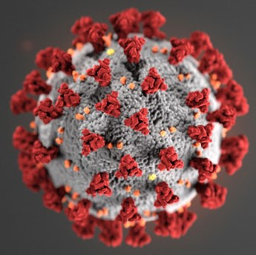
Health Mandate 10.1 – International and Interstate Travel – Order for Self-Quarantine
Upon arrival in any community in Alaska from another state or nation, you must:
- Stay on your vessel or proceed directly from the vessel to your designated quarantine location, which is the location identified and affirmed by you on the mandatory State of Alaska Travel Declaration Form.

- Remain in your designated quarantine location for a period of 14 days, or the duration of your stay in Alaska, whichever is shorter.

If your business meets the criteria identified in Alaska Essential Services and Critical Workforce Infrastructure Order, you must submit a plan or protocol for maintaining critical infrastructure to the Unified Command as soon as possible.
https://covid19.alaska.gov/unified-command/worker-mitigation-plan/

The failure to follow this order is punishable by a fine of up to $25,000, or imprisonment of not more than one year, or both pursuant to Alaska Statute 12.55.035 and Alaska Statute 12.55.135

For further information and direction please call the Homer Harbor Office at
907-235-3160 during office hours or on VHF Channel 16 (available 24/7)
Call 911 for emergencies.

